Dear _____________________

Your interview is on:

Day: ____________________

Time: ____________________

Address: ____________________

You will be asked questions about the job.

You can bring a person to support you.

 | There will be three people asking you questions.
You will be asked:

- Why do you want this job?

- What skills and qualities do you have that would be good for this job?

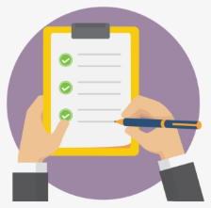 | Please bring copies of:  - Any certificates for training you have completed  - Evidence of Intellectual Disability
 | You can ask questions about the job.
5 days after the interview you will be told if you are offered the job.

If you do not get the job you can ask for information on how you can improve for your next interview.

If you have any questions before your interview,
please call ____________

Looking forward to meeting you.

Regards
_________________________

